Task 8: Data Versioning and Lineage
RecoMart — End-to-End Data Management Pipeline for a Recommendation System
Data Management for Machine Learning (AIMLCZG529/DSECLZG529), S2-25
This document explains how we versioned our raw and transformed data for this project, and why we ended up choosing DVC (Data Version Control) over Git LFS after running into a real limitation.

1. Why We Needed a Versioning Approach
Our raw data source (the Kaggle REES46 clickstream CSV) is large - about 5.28 GB uncompressed. Our ingestion script (ingest_kaggle_batch.py, from Task 2/3) is designed to run repeatedly over time, writing each run's data into a new timestamp-partitioned folder (ingestion_date=YYYY-MM-DD/) rather than overwriting the previous one. This already gives us multiple versions of the raw data sitting on disk. Task 8 asks us to formally track and document these versions using a tool like DVC or Git LFS.

2. Why We Chose DVC Over Git LFS
We initially tried Git LFS, since it's simpler to set up and works directly with GitHub. However, we ran into a hard limitation: GitHub's free tier caps LFS storage and bandwidth at 1 GB, and our raw CSV alone is 5.28 GB per version. Attempting to push it resulted in a failed push, and having two versions (July 9 and July 12) would have meant over 10 GB total - nowhere close to feasible on the free tier.
DVC solves this differently: instead of uploading the actual large file anywhere, it creates a small pointer file (a .dvc file, only a few hundred bytes) containing a hash/fingerprint of the data. Only this tiny pointer file goes into Git - the real data stays on our local machine. This let us version the dataset without hitting any size or bandwidth limits, at the cost of the actual data not being remotely accessible to others (acceptable for this assignment, since we are working solo and the point is to demonstrate the versioning mechanism, not to host multi-GB files for public download).

3. What We Actually Did
Steps taken, in order:
git init # initialized Git in our working folder
dvc init # initialized DVC (requires a Git repo to sit inside)
dvc add "...ingestion_date=2026-07-12\2019-Oct.csv" # tracked the July 12 raw data version
git add ... && git commit -m "Task 8: Initialize DVC tracking for raw data (2026-07-12 ingestion)"
dvc add "...ingestion_date=2026-07-09\2019-Oct.csv" # tracked the July 9 raw data version
git add ... && git commit -m "Task 8: Track July 9 raw data version with DVC"
Each dvc add command produced a small .dvc file next to the real data file, and DVC also automatically added a .gitignore rule so that Git would never accidentally try to track the huge raw file itself, only the small pointer.
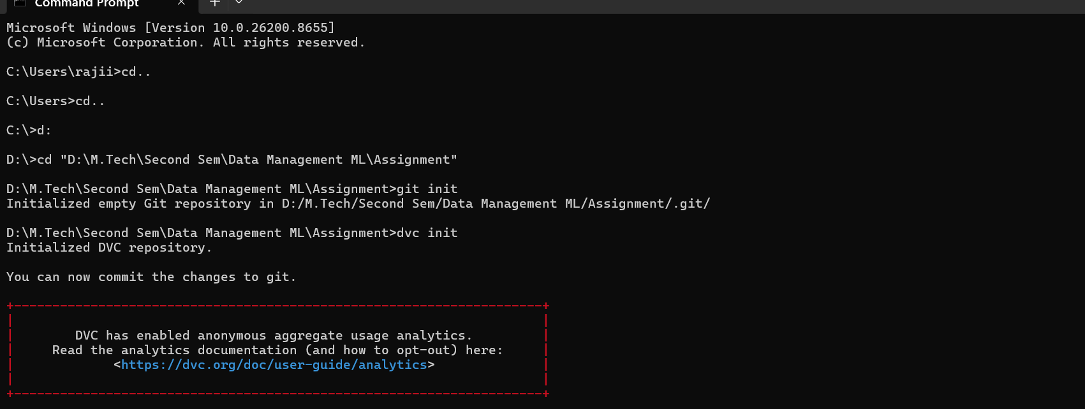
Screenshot: git init and dvc init running successfully in our project folder.
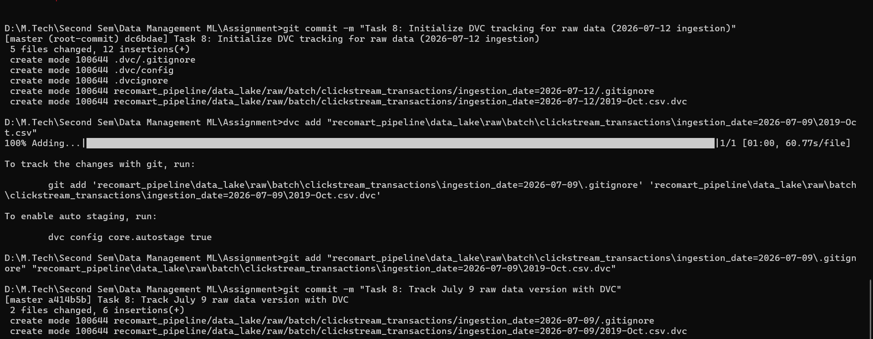
Screenshot: dvc add completing on the raw CSV (5.28 GB, ~1 minute to process), followed by git add and git commit saving the version.

4. Resulting Repository Structure
Our Git commit history now shows two distinct, dated versions of the raw dataset:
a414b5b (HEAD -> master) Task 8: Track July 9 raw data version with DVC
dc6bdae Task 8: Initialize DVC tracking for raw data (2026-07-12 ingestion)
Each commit corresponds to one ingestion_date folder and contains:
recomart_pipeline/data_lake/raw/.../ingestion_date=2026-07-09/2019-Oct.csv.dvc
recomart_pipeline/data_lake/raw/.../ingestion_date=2026-07-12/2019-Oct.csv.dvc
Each .dvc file contains a content hash of its corresponding raw file. This means if the raw data ever changed between ingestion runs, the hash in a newly-added .dvc file would differ, giving us a verifiable way to detect and confirm that the data actually changed, not just that a new folder was created.

4b. Verification
To confirm the versioning was actually saved (not just run once and forgotten), we re-ran git log --oneline in a fresh terminal session and got the same two commits back, confirming the history is genuinely persisted in our local Git repository:
a414b5b (HEAD -> master) Task 8: Track July 9 raw data version with DVC
dc6bdae Task 8: Initialize DVC tracking for raw data (2026-07-12 ingestion)
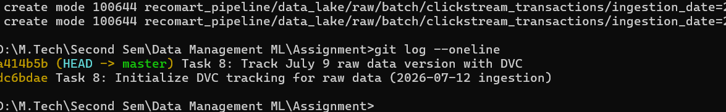
Screenshot: git log --oneline re-run in a fresh terminal session, confirming both commits are genuinely persisted.

"Each commit is identified by a short hash (e.g., a414b5b) — a unique fingerprint Git generates for that exact snapshot, shown here to prove these are real, verifiable commits."

5. Metadata Tracked
Metadata | How It's Tracked
Data source | Kaggle REES46 e-commerce clickstream dataset
Date of ingestion | Captured directly in the folder name (ingestion_date=YYYY-MM-DD), created automatically by ingest_kaggle_batch.py each time it runs
Applied transformations | Not applied at the raw layer (raw data is kept untouched, per our Task 3 approach). Transformations are tracked separately via our Task 6 SQL schema and Task 7 feature registry
Version identity | Content hash stored inside each .dvc pointer file, plus the Git commit message and commit hash

6. Local Storage Note
The .dvc pointer files (and the version history they represent) are pushed to GitHub as part of our repository, so anyone can see exactly how many versions exist, when each was created, and their content hashes. The actual raw data files stay on the local machine they were ingested on, since DVC is designed to separate 'tracking metadata' (small, goes in Git) from 'actual data' (large, stays wherever it is). For a production setup, DVC supports connecting a remote storage backend (S3, Google Drive, Azure Blob, etc.) so the real data could be pulled by anyone with access to that remote - we kept this local-only since it fully demonstrates the versioning mechanism Task 8 asks for, without needing to set up and pay for external cloud storage for a class assignment.

